Freshwater constraints map

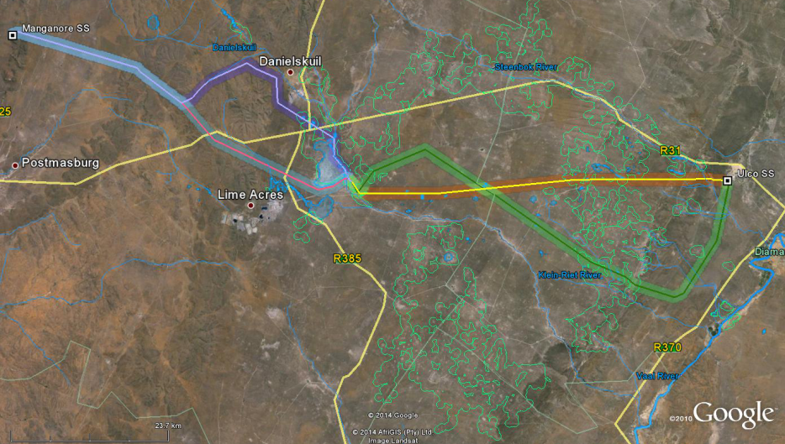
4
3
2
1

No. | Google Earth image | Comment
1 |  | First and Second Alternative:  No freshwater features of any significance are crossed by the proposed route for this section, except for some smaller tributaries of the Groenwaterspruit in its upper reaches. A 50m buffer on either side of the centre line of the drainage channel is advised. The route selected within the corridor should be such that the number of drainage line crossings is minimised as far as possible and that the road be located outside of the recommended buffer except for where it needs to cross the watercourse. The crossing should preferably be placed perpendicular to the watercourse and the disturbance to the watercourse minimised as far as possible.  Manganore Substation:  There is no proposed expansion of the substation.

2 | 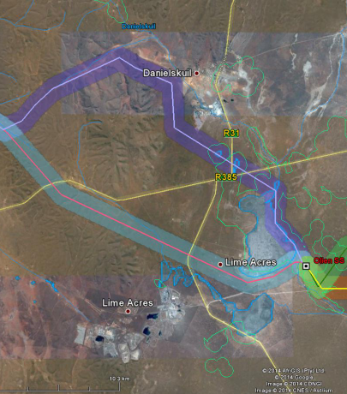 | First Alternative (purple line):  This alternative route is located adjacent to the Great pan as well as some smaller pans between the Olien Substation and Danielskuil. By placing the line on the outer (northern) edge of the corridor, it would largely be located outside for the pans and their buffer (green lines in Google Earth image), with the exception of the inflow into the Great pan. If this alternative was selected on would need to investigate a route alignment that have the least impact when crossing within the buffer. For the remainder of the route it is also located to the Danielskuil Stream in the upper reaches of the Klein-Riet River. A 50m buffer on either side of the centre line of the drainage channel is advised.  Second Alternative (blue line):  This alternative route crosses a small tributary of the Klein-Riet River upstream of Rooipan. A 50m buffer on either side of the centre line of the drainage channel is advised.  Olien Substation:  The existing substation is surrounded with small pans and the drainage from the Great Pan to the west and south. It is thus recommended that any expansion to the substation take place to the east of the existing line and along the railway line.

3 | 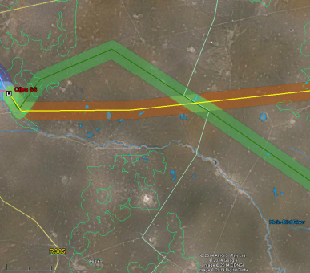 | First Alternative (orange line):  This section of the First alternative route would cross a few smaller pans for much of the route. The only larger pans of concern are located close to the Olien Substation. The proposed route is following the alignment of existing power lines at this point. By placing the line on the outer (northern) edge of the corridor, it would largely be located outside for the pans and their buffer (green lines in Google Earth image)  Second Alternative (green line):  This alternative route would also only cross a few minor pans on this section of the route with the exception of the section closest to the Olien Substation. This route should preferably follow as close to the railway line as possible to avoid crossing the pans in this section.
4 | 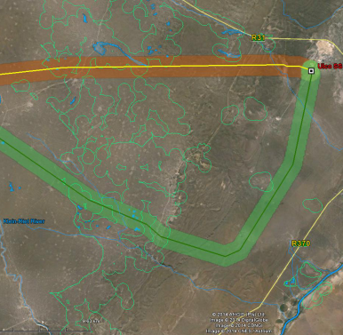 | First Alternative (orange line):  This section of the First alternative route would cross a few smaller pans for much of the route. By placing the line on the outer (southern) edge of the corridor, it would largely be located outside for the pans and their buffer (green lines in Google Earth image). The proposed route will also need to cross over the Steenbok River. The crossing should preferably be placed perpendicular to the watercourse (allowing for a 50m buffer between the centre of the watercourse and any structures associated with the power line) and the disturbance to the watercourse minimised as far as possible.  Second Alternative (green line):  This alternative route would cross a number of minor pans as well as a small tributary of the Klein-Riet and the Steenbok River on this section of the route. One could align the route of the power line to avoid crossing the pans and their buffers as far as possible. With regards to the crossings over the small streams, the crossings should preferably be placed perpendicular to the watercourse (allowing for a 50m buffer between the centre of the watercourse and any structures associated with the power line) and the disturbance to the watercourse minimised as far as possible.  Ulco Substation:  There are no freshwater features in close proximity to the existing substation. The closest freshwater feature is the Steenbok River approximately 2.5km to the south-west of the substation.

